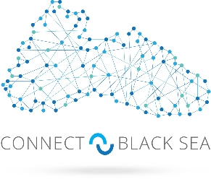
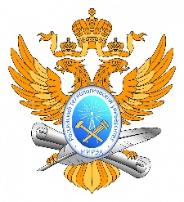

REGISTRATION FORM

Roundtable
“STAFFING AND EDUCATIONAL PROGRAMS IN THE FIELD OF INTEGRATED MANAGEMENT AND SUSTAINABLE DEVELOPMENT OF MARITIME ACTIVITIES
OF THE RUSSIAN FEDERATION”
Webinar "Interdisciplinary educational technologies for a "blue economy"

November 25, 2021, 14.00-18.00 (MSK)
Moscow, RTU MIREA, 78 Vernadsky Avenue
(hosted in a hybrid format)
FULL name
Е-mail
Organization
Position
Form of participation (underline/highlight) | In person  Online
Form of participation: participant /key speaker | Participant  Key speaker
Abstract title (Topic of the presentation)
please, attach the Abstract text of max 1 page to this form in case of participation with a presentation

Please send the completed registration form to the address: marine@mirea.ru with a copy to bsc2021@bk.ru

ALL fields are MANDATORY.
Deadline for registration and submission of abstracts: November 23, 2021.

Coordinators:
Galina Baturova, mob. +7-903-779-39-41
Larisa Danilova, mob. +7-921-559-35-95

